MP3 format

(MPEG -1 or MPEG -2 Audio Layer 3)

- Tushar Mudgal ,Bharati Vidyapeeth College of Engineering

**What is MP3?**

**MP3 format** is an audio compression tool that reduces the size of audio file without affecting the quality of sound. Today, thousands of mp3 files are shared across the world. With this format a 20 megabyte song is compressed into about 2 megabyte. It not only allows a fast access to a file but it also saves a lot of storage space. It has changed the traditional ways which people used to listen and store music.

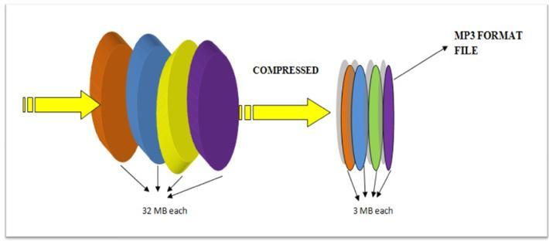

**Need of MP3 format**

Well coming to the facts, do you know that the data stored on a CD in straight line is about 4 miles long. Surprised!

Ok let’s do some arithmetic calculations to understand.

Music in CD’s is sampled at 44,000 times per second (44 kHz). The samples are 2 bytes (16 bits) long. So total sampling bits would be equal to 44 kHz * 16 bits which equal 704 Kbits /sec. Also separate samples are taken for left and right speakers so the total sampling bits would be 704 Kbits /sec * 2 equals roughly 1.4 million bits per second.

Now, an average song is about 3 minutes long i.e. 180 seconds, then the average song on a CD consumes about 32 million bytes (or 32 megabytes) of space. This data is uncompressed with high resolution. When this data is stored in desktops or mobile storage, it occupies a large amount of data. In other situation if we want to download this data it can takes several minutes to download over the internet, even with high speed cable or DSL Modem.

The solution to this kind of problem was MP3 which will compress the data without affecting the quality of sound.

**But the question is how to compress the file without hurting the quality of audio file?**

As we all use .jpg and .gif files that compresses the images or the zip files that compress text all the time. The same concept is used in audio compression. Both these methods make use of **compression algorithms.**

**Compression algorithm-** is a technique used in computer science that encodes information using fewer bits than the original representation. It is just like a telegram where unnecessary words are removed without losing the meaning of the message.

Similarly, the compression algorithms are developed for audio that removes the certain parts of the audio without hurting the quality of music. To make a good compression algorithm for sound, a technique called **perceptual noise shaping** is used. It's "perceptual" partly because the MP3 format uses characteristics of the human ear to design the compression algorithm.

**Perceptual Noise shaping-**Perceptual noise shaping is a technique used to develop compression algorithms that converts audio files to MP3 files. The figure below presents three different scenarios with prospect to our human ear.

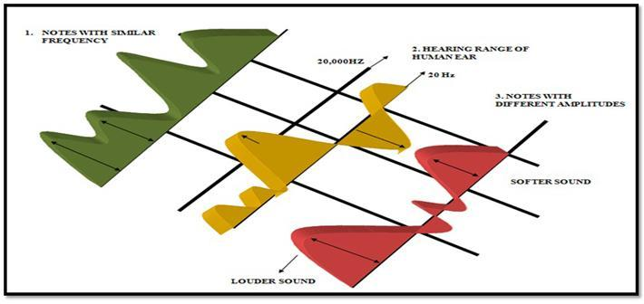

**Perceptual noise shaping algorithm:**

The explanation below clears the picture how the technique of perceptual noise shaping is works:

1. **Some sound frequencies can be heard by human ear better than others**. For example if two notes are very similar and close together as shown by two pink arrows. Our brain will perceive only one of them.
2. There are some frequencies that can’t be heard by a human ear because **our hearing ranges only from 20 Hz to 20,000 Hz.** All the frequencies above and below this range are not heard by human ear. The blue arrow lies below 20 Hz so it will be removed from the audio.
3. A Louder sound will drown out the softer sound if they are played simultaneously. When a drum and a flute are played together as shown by orange arrows, our brain will be more focused on beats of the drum as compared to flute. Using these three facts entire compression algorithm is designed which is known as psychoacoustics model to eliminate certain parts of the song without significantly hurting the quality of the song for the listener. Compressing the rest of the song with well-known compression techniques shrinks the song considerably -- by a factor of 10 at least. When you're done creating an MP3 file, what you have is a song with reduced size and of acceptable quality.